Finding Filters
The saved Filters can be accessed on the Issue Navigator page via the 'Manage' (7) tab at the top of the Search Side-bar or the 'Manage Filters' menu item at the bottom of the Issues drop-down menu. Both of these lead to the 'Manage Filters' page where lists of existing Filters can be viewed.
There are 4 categories of Filter shown on the Manage Filters page, each has its own tab (8).
- Favorites: Filters can be set as Favorites either when they are created or by Editing them later. The star next to 'Favorite', in the Filter's properties, is yellow when a Filter is in Favorites and gray when it is not.
- My: All of the Filters created by the current user are listed here
- Popular: These are Filters that have been saved and shared by other users. Listed according to frequency of use
- Search: Finds shared Filters based on their names, descriptions, who created them and how widely they are shared.
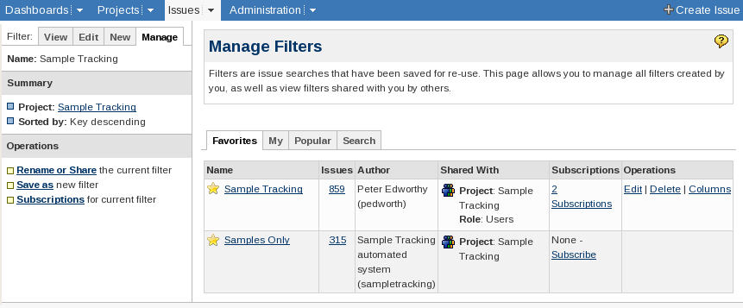
Manage Filters Page
7
9b
9a
8

Using, Modifying and Removing Filters
Clicking on the name of a Filter returns to the Issue Navigator and the Search is carried out.
Filters can be used or modified via the 'Operations' listed in the Search Side-bar (9a) and the 'Operations' column (9b) of the Manage Filters page. Operations only act on a single Filter: The Search Side-bar Operations (9a) act on the current Filter; Each cell in the 'Operations' column is specific to that rows Filter.
Filters that were created by other users cannot be modified and so do not have any Operations in the 'Operations' column and do not have an 'Operations' section in the Search Side-bar.
The Filter management functionality is a bit mixed between the 'Manage Filters' page and the 'Operations' sub-menu.
Rename or Share (Search Side-bar), Save as (Search Side-bar), Edit (Manage Filters)
All three bring up the same page as was used for the 'Save' page. 'Save as' copies the Filter creating a new Filter, it does not change the original Filter. 'Rename or share' and 'Edit', however, modify the existing filter
Subscriptions (Search Side-bar), Subscribe (Manage Filters)
Subscriptions are automatically run Filters whose results are emailed to users.
Delete (Manage Filters)
The conformation dialog contains a count of how many subscribers there are to the filter.
Columns (Manage Filters)
The columns displayed when viewing the results of a search/filters can be modified (by adding, removing and rearranging columns). Modifying the default Column settings is covered later in XXXXXXXXXXX. The process of setting u

Subscriptions
Subscriptions are Filters that are run at preset intervals and whose results are then emailed to the Subscribers. Shared Filters can be used, but with the following caveats:
- The creator of a Filter can see all of the Subscriptions using that Filter
- When using a Filter created by another User only the Subscriptions made by the current User will be visible.
- Only the user who created a Subscription can modify that Subscription*
* The Filter's creator cannot edit or delete individual Subscriptions on a Filter but they can delete the Filter which in turn deletes all of the Subscriptions that were using that Filter.

Manage Filters Page
The 'View Subscriptions' page for a particular Filter can be reached either via the 'Subscriptions' link in the 'Operations' section of the Search Side-bar (1a) or via the 'N Subscriptions' links in the 'Subscriptions' column of the 'Manage Filters' page.
Manage Filters Page: Subscription options
1a
1b
2
If no Subscriptions are listed (2) then the link on the 'Manage Filters' page leads to the 'Create Subscription' page instead of the 'View Subscription' page.

View Subscriptions Page
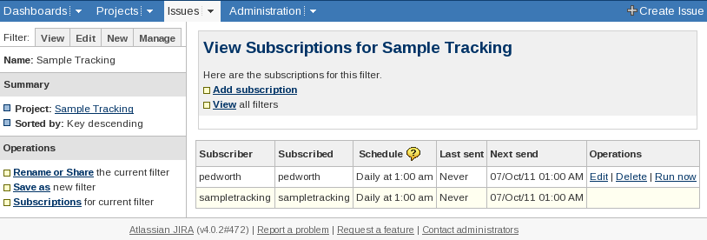
View Subscriptions page
The 'View Subscriptions' page lists a subset of the Subscriptions that use that Filter. (See Error: Reference source not found)

Subscription page
The Subscription page is used for creating and editing Subscriptions. It controls who is emailed and how often.

Creating a Subscription
Subscriptions can be created either via the 'Add Subscription' link on the 'View Subscriptions' page or a 'Subscribe' link on the 'Manage Filters' page.

Editing a Subscription
Editing Subscriptions is only done using the 'Edit' link in the 'Operations' section of the 'View Subscriptions' page
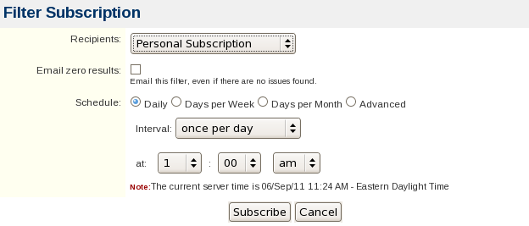
Manage Filters: Subscribe

